Insert the Area Council logo here

____________ Area 4-H Communications

date

time

location - town

(borders on tables are for ease of filing only – remove for printing purposes)

|  |  |  |  |
| --- | --- | --- | --- |
| **Room 1 – (give room name or number)** | | | |
| Name | Club | Category | Title |
|  |  |  |  |
|  |  |  |  |
|  |  |  |  |
|  |  |  |  |
|  |  |  |  |
|  |  |  |  |
|  |  |  |  |
|  |  |  |  |
|  |  |  |  |
|  |  |  |  |
|  |  |  |  |
|  |  |  |  |
|  |  |  |  |

|  |  |  |  |
| --- | --- | --- | --- |
| **Room 2 – (give room name or number)** | | | |
| Name | Club | Category | Title |
|  |  |  |  |
|  |  |  |  |
|  |  |  |  |
|  |  |  |  |
|  |  |  |  |
|  |  |  |  |
|  |  |  |  |
|  |  |  |  |
|  |  |  |  |
|  |  |  |  |
|  |  |  |  |
|  |  |  |  |

|  |  |  |  |
| --- | --- | --- | --- |
| **Room 3 - (give room name or number)** | | | |
| Name | Club | Category | Title |
|  |  |  |  |
|  |  |  |  |
|  |  |  |  |
|  |  |  |  |
|  |  |  |  |
|  |  |  |  |
|  |  |  |  |
|  |  |  |  |
|  |  |  |  |
|  |  |  |  |
|  |  |  |  |
|  |  |  |  |
|  |  |  |  |
|  |  |  |  |
|  |  |  |  |
|  |  |  |  |

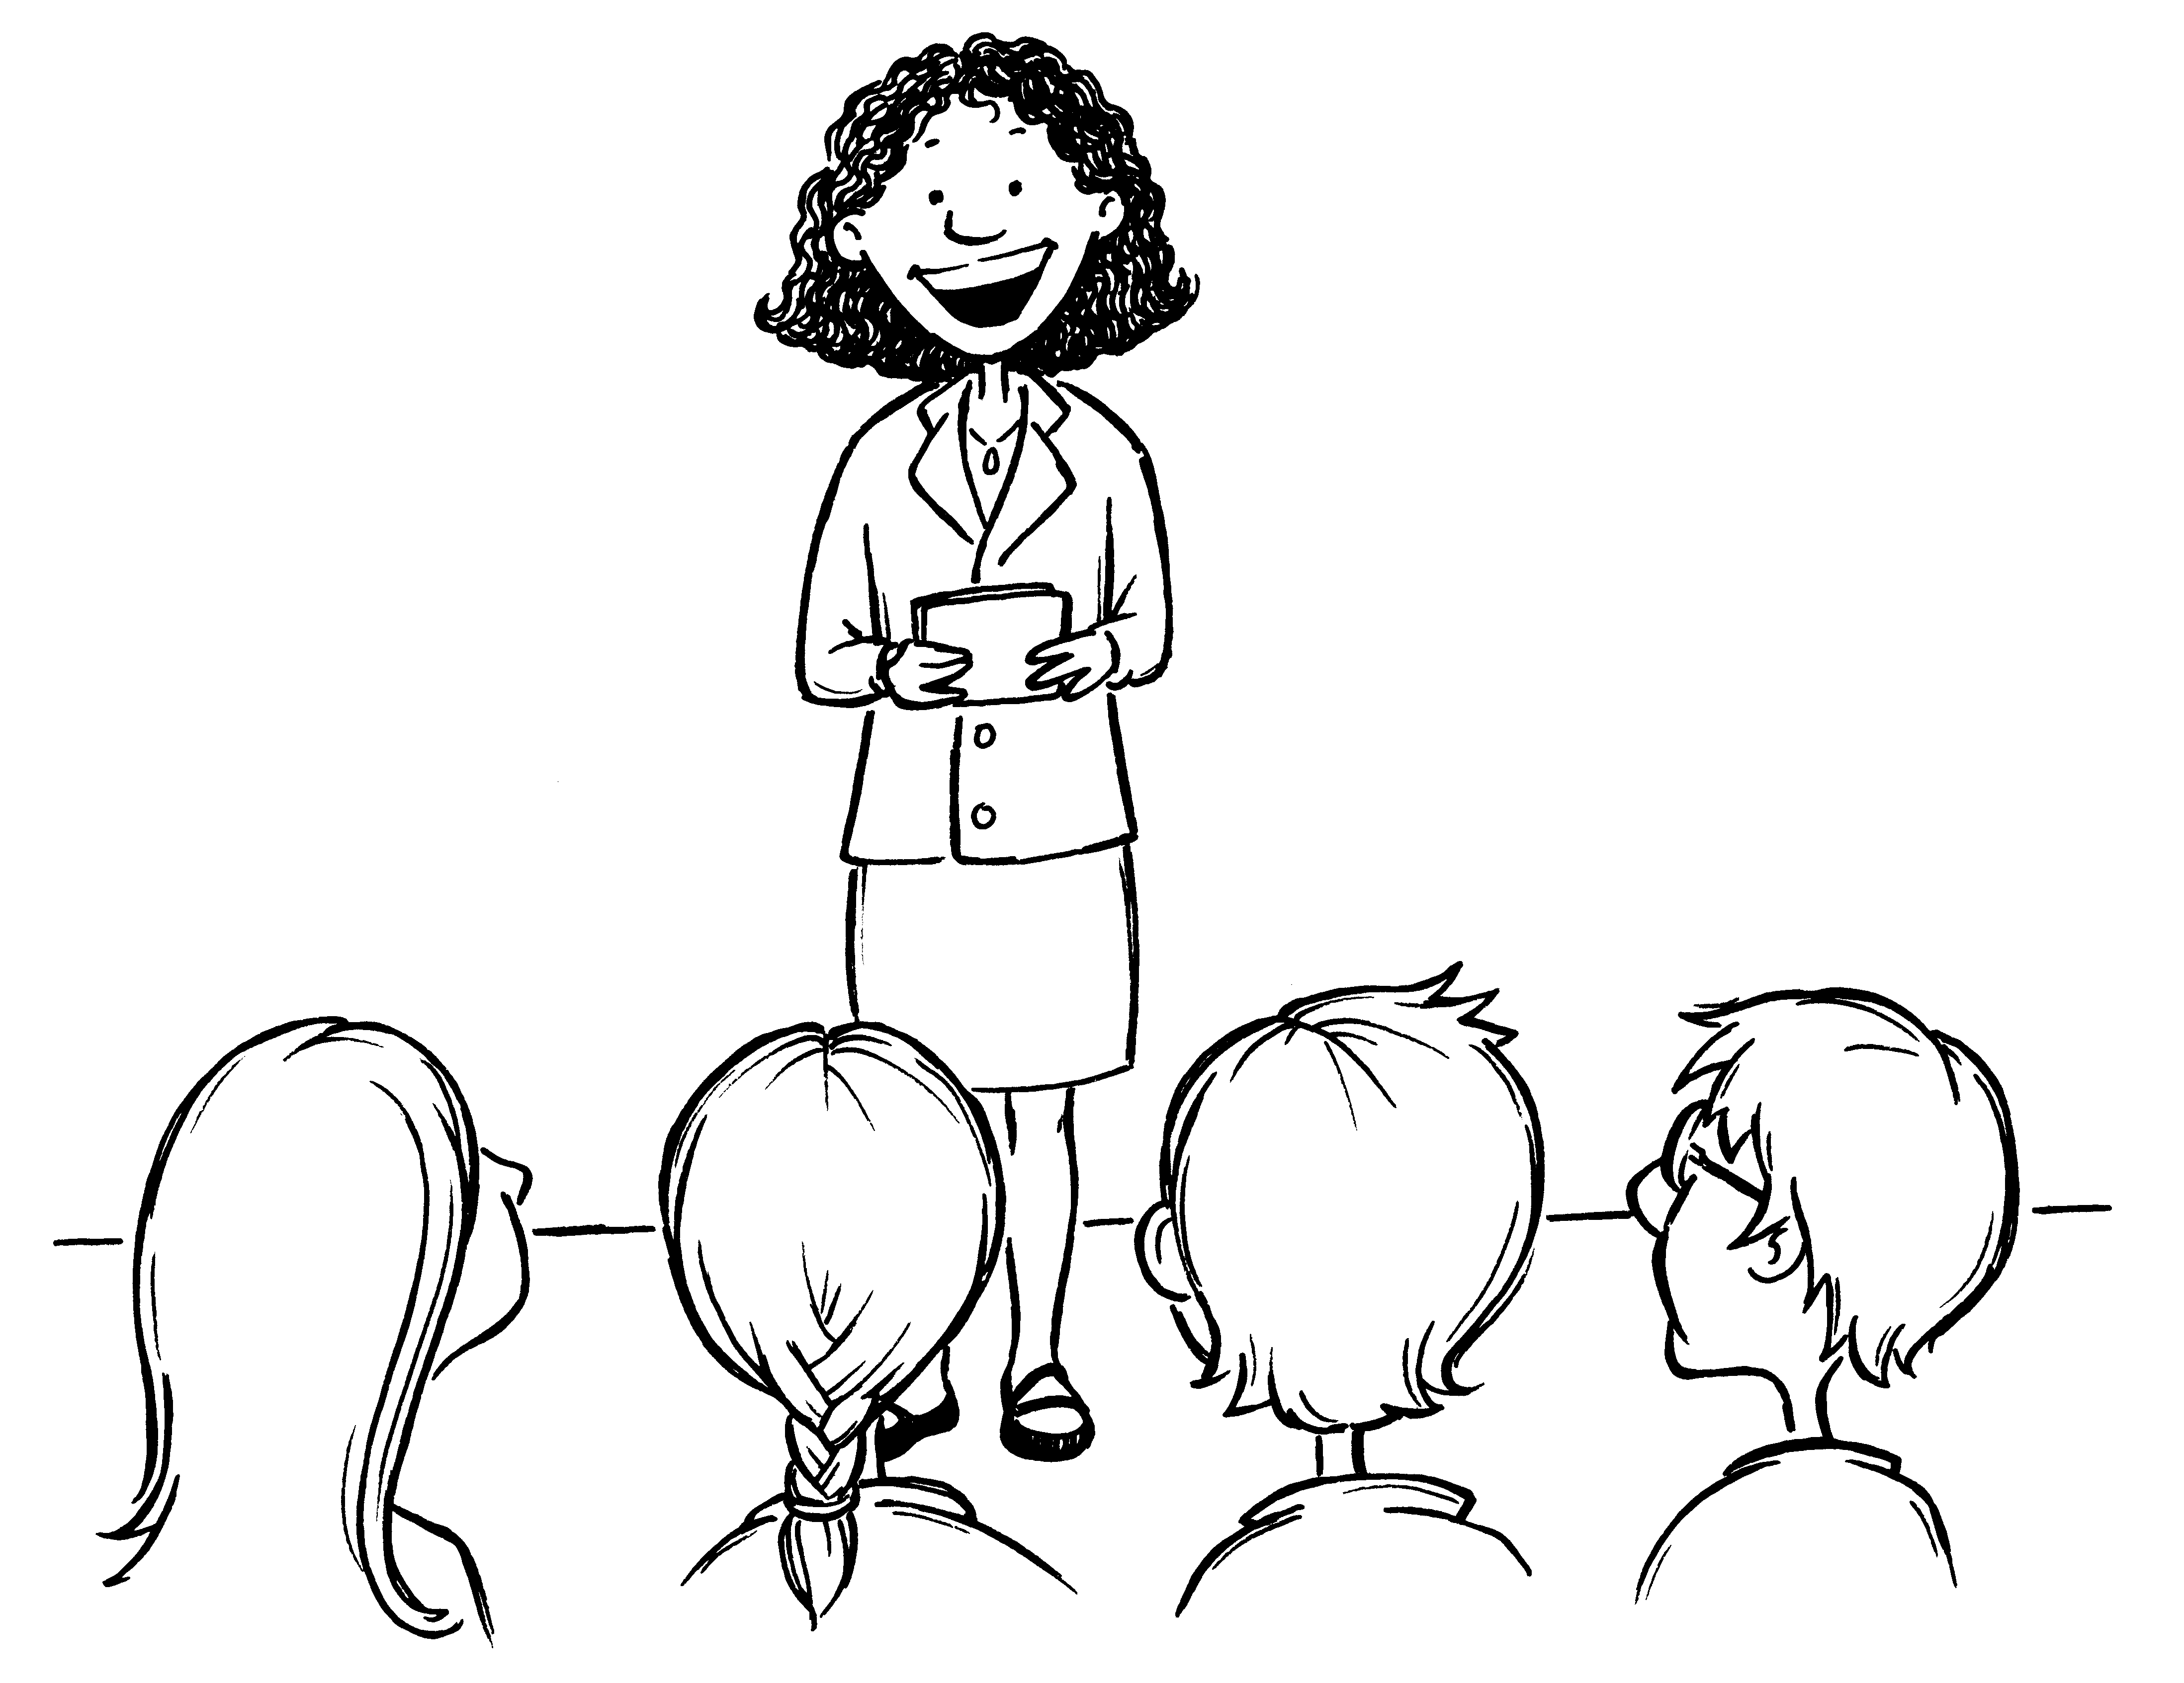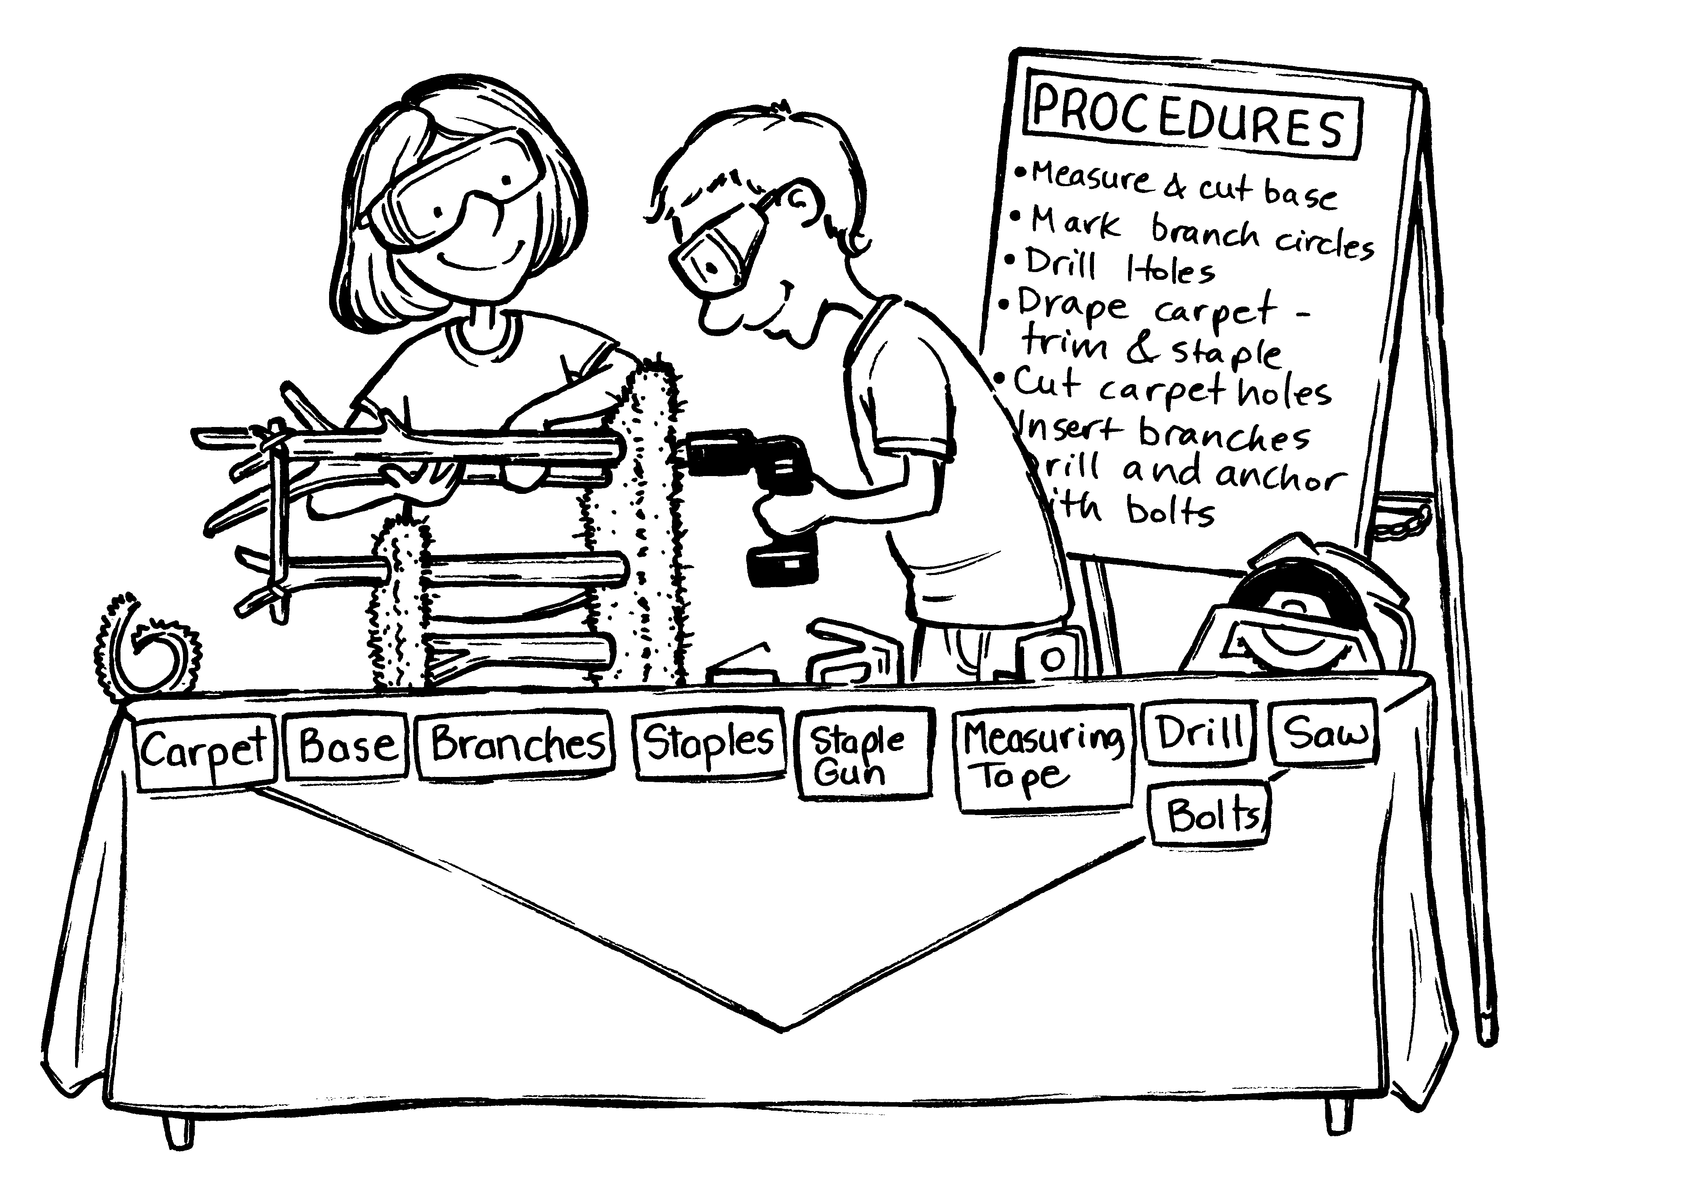

Here you can state where and when the award presentations will take place.

e.g.

The awards presentation will take place in Room 1 – the Main Auditorium, immediately following the conclusion of all category competitions.

Insert area council logo here if there is room

**The _______________**

**Area 4-H Council**

Would like to thank the following

sponsors and volunteers

for their support

|  |
| --- |
| List sponsors here - usually in order of size of donation |
| Grid lines can be removed before printing |
|  |
|  |
|  |

|  |  |
| --- | --- |
| **Judges** | |
| Cloverbud Speeches & Adult Speeches | Names of judges on this side |
| Junior Speeches | Grid lines can be removed before printing |
| Junior Visuals | This chart shows an example of how the categories could be grouped for judges |
| Intermediate Speeches & Intermediate Visuals |  |
| Senior Speeches |  |
| Cloverbud Visuals & Adult Visuals |  |
| Senior Visuals |  |

